


King Saud University
College of Computer and Information Sciences Department of Information Systems

IS316: data science
2st Semester 1447 H

NAME
Jumanah Ibrahim
Arwa Almutairi
Dana Alturki
Shatha munif

Supervised By:shatha al tamami.
Second Semester 1447
May 2026

Introduction (Problem & Objectives)

The increasing prevalence of diabetes has become a major global health concern, making early risk prediction essential for prevention and treatment. The problem addressed in this project is the ability to accurately classify individuals into different diabetes risk categories based on their health and lifestyle features.

The objective of this project is to build machine learning models that can predict the diabetes risk category (Low Risk, Prediabetes, High Risk) using patient-related data such as age, BMI, glucose levels, and other health indicators. This helps in identifying individuals at risk and supports early medical intervention.

The main research questions guiding this project are:
- Which features are most influential in predicting diabetes risk?
- How does the distribution of risk categories affect model performance?
- Which machine learning model provides the best predictive performance?

This problem is important in the real world because accurate prediction models can assist healthcare providers in early diagnosis, reduce complications, and improve patient outcomes through preventive care.

Date Overview

1. Dataset Description (Size, Features, & Target)
- Data Scale: The dataset consists of 6,000 records and 19 features, providing a robust sample size for training and testing machine learning models.
- Feature Selection: Out of the 19 available features, our analysis prioritizes key metabolic and lifestyle indicators, such as Fasting Glucose Level, HbA1c Level, BMI, and Insulin Level.
- Target Variable: The goal is to predict the diabetes_risk_category, which classifies patients into three distinct levels: Low Risk, Prediabetes, or High Risk.
2. Key Findings from EDA
- Class Imbalance: A significant finding during EDA was the class imbalance; the "Low Risk" category represents approximately 50% of the dataset, which required careful consideration during the modelling phase to avoid bias.
- Age Distribution: The age of participants is uniformly distributed between 20 and 80 years, ensuring the model's findings are not biased toward a specific age group.
3. Relevant Visualizations
- Count Plot: Used to visualize the distribution of the three risk categories and identify the class imbalance.
- Histograms: Used to analyse the uniform distribution of Age across the dataset.
- Box Plots: Used to demonstrate the significant increase in Fasting Glucose levels as the risk category shifts from Low Risk to High Risk. It also highlights the presence of outliers and the spread of glucose values within each category
- Scatter Plot: Used to visualize the relationship between Age and BMI. It demonstrates a clear stratification where the Risk Level transitions from Low to High as BMI increases, regardless of the patient's age
- Heatmap: Used to identify the correlation between various health metrics and the target variable.

Methodology (Preprocessing & EDA)

Data Preprocessing

At the beginning, we cleaned and prepared the dataset before starting the analysis.

We checked for missing values in all columns, and we found that there were no missing values, so no changes were needed in this step.

Then, we checked the data types. Most of them were already correct, but we converted the Patient_ID column into a string because it represents an identifier and not a numerical value.

After that, we checked for duplicate records, and we found that there were no duplicates, so no rows were removed.

For the categorical features such as gender, physical activity level, family history of diabetes, and diabetes risk category, we applied encoding to convert them into numerical values so they can be used in modeling.

Outlier Detection

To detect outliers, we used the IQR method on all numerical features.

We found that some features like fasting glucose level, HbA1c level, cholesterol level, and daily calorie intake contain noticeable outliers. On the other hand, features such as age, sleep hours, and stress level have fewer outliers.

At this stage, we did not remove all outliers directly. Instead, we analyzed them first, and then handled extreme values to make the data more consistent.

Exploratory Data Analysis (EDA)

We used different visualizations to better understand the dataset.

The count plot showed that most individuals are in the Low Risk category, which indicates a slight imbalance in the data.

The histogram of age showed that the data is relatively evenly distributed across different age groups.

The box plot showed that individuals in the High Risk category tend to have higher glucose levels compared to other groups.

The scatter plot between age and BMI showed that higher BMI is more common among individuals with higher risk levels.

Finally, the heatmap showed strong relationships between some features. For example, fasting glucose level is strongly correlated with HbA1c level, and BMI is related to waist circumference and diabetes risk.

Summary of EDA Insights

From the analysis, we observed that glucose-related features, BMI, and waist circumference are important factors in predicting diabetes risk.

These insights helped us better understand the dataset and guided our preprocessing decisions.

Modeling & Results

In this phase there were multiple models were implemented to predict diabetes risk with different approaches.

Models used:
1-logistic regression (line)
2-support vector machine (SVM) (margin based)
3- random forest (ensemble)

Evaluation metrices
- Accuracy
- Precision
- Recall
- F1-score

results

model | accuracy | precision | recall | F1-score
Logistic regression | 0.81 | 0.80 | 0.81 | 0.72
SVM | 0.91 | 0.92 | 0.91 | 0.91
Random forest | 0.91 | 0.91 | 0.91 | 0.91

visualization
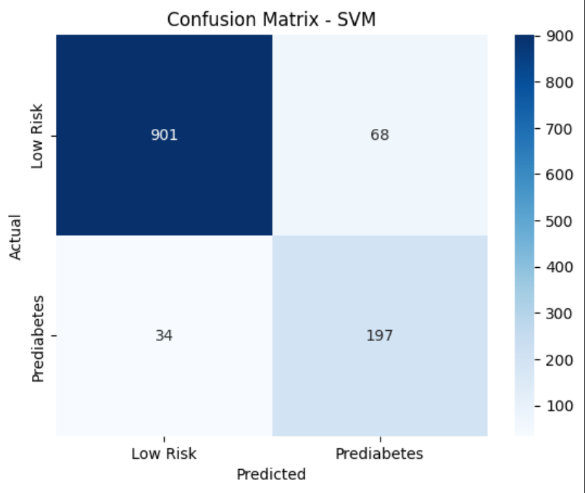

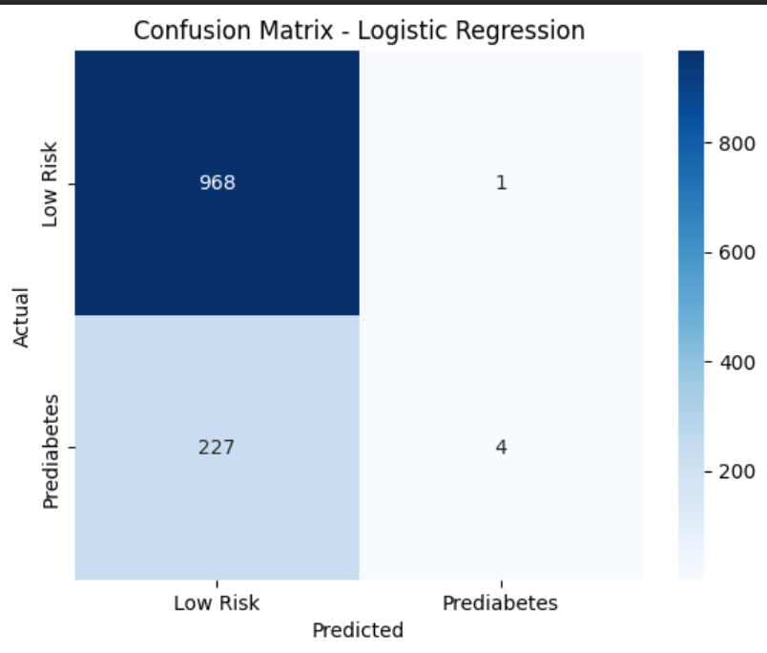
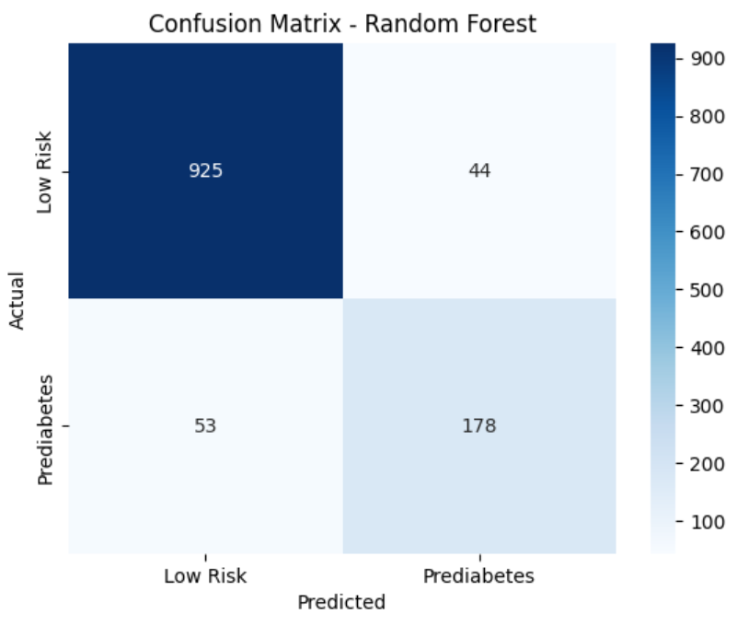
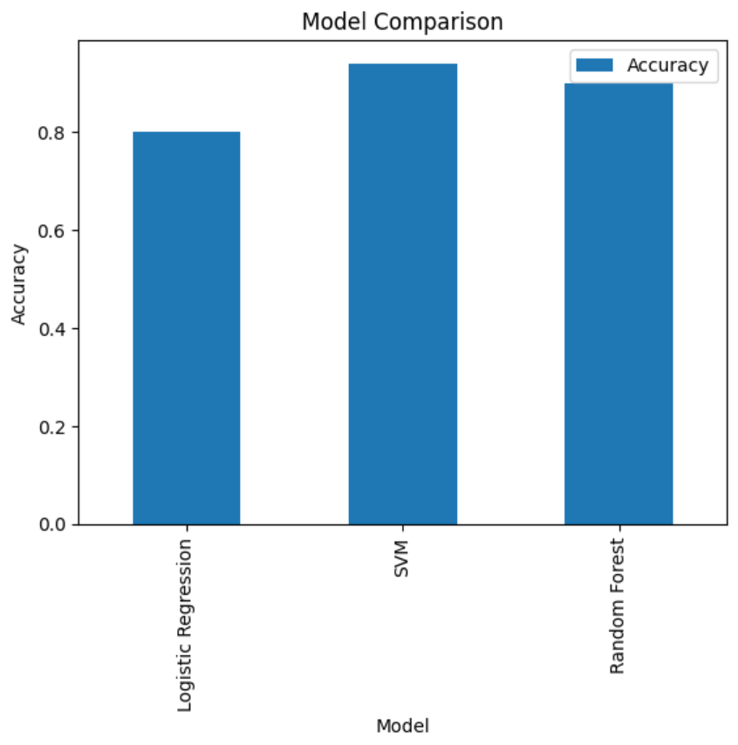
Visualization results

As a result, the SVM model was able to achieve optimal performance overall compared to the rest of the tested models with high accuracy and balanced precision and recall.
The performance of Logistic Regression is even lesser owing to its simplistic model in capturing complicated relationships.
At first Random Forest perfectly classified the training set and this suggested data leakage. Removing highly correlated features made its performance more realistic.
Overall, SVM provided the best balance between accuracy and generalization

Conclusion

This project aimed to develop machine learning models to predict diabetes risk categories based on health-related features. The results demonstrated that the models were able to effectively classify individuals into different risk groups with good performance.

During the modeling phase, an initial issue was identified where the Random Forest model achieved 100% accuracy. This was found to be unrealistic and indicated the presence of overfitting caused by data leakage. Specifically, the feature diabetes_risk_score was highly correlated with the target variable, allowing the model to indirectly access the correct labels. After removing this feature, the model performance became more realistic, with accuracy values around 91%, reflecting true predictive capability.

Among the evaluated models, Support Vector Machine (SVM) achieved the highest accuracy, closely followed by Random Forest. Although SVM performed slightly better in terms of accuracy, Random Forest demonstrated strong and stable performance, making it a reliable model for this classification task. In contrast, Logistic Regression showed lower accuracy but maintained simplicity and stability.

Additionally, the results were consistent with the findings from the exploratory data analysis. Features such as glucose level and BMI were identified as important factors influencing diabetes risk, indicating that the models successfully captured meaningful patterns in the data rather than random relationships.

However, several limitations were identified. The dataset exhibited class imbalance, which may affect the model’s ability to accurately predict minority classes. Furthermore, the number of features was limited, and important factors such as family history or lifestyle habits were not included. As a result, the model may not perform equally well when applied to new real-world data.

For future improvements, several enhancements can be considered. These include applying hyperparameter tuning to optimize model performance, addressing class imbalance using techniques such as SMOTE, and incorporating additional features to better represent real-world conditions.

In conclusion, this project demonstrates that machine learning models can effectively predict diabetes risk and provide valuable insights for early detection. Such models can support healthcare decision-making and contribute to preventive strategies aimed at reducing the impact of diabetes.

